OS Practical-3
Output:
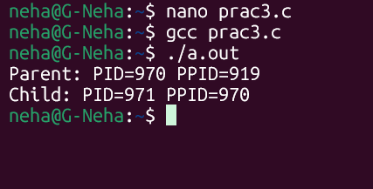
Commands:
1.ps:
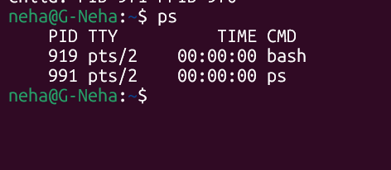
2.Top:
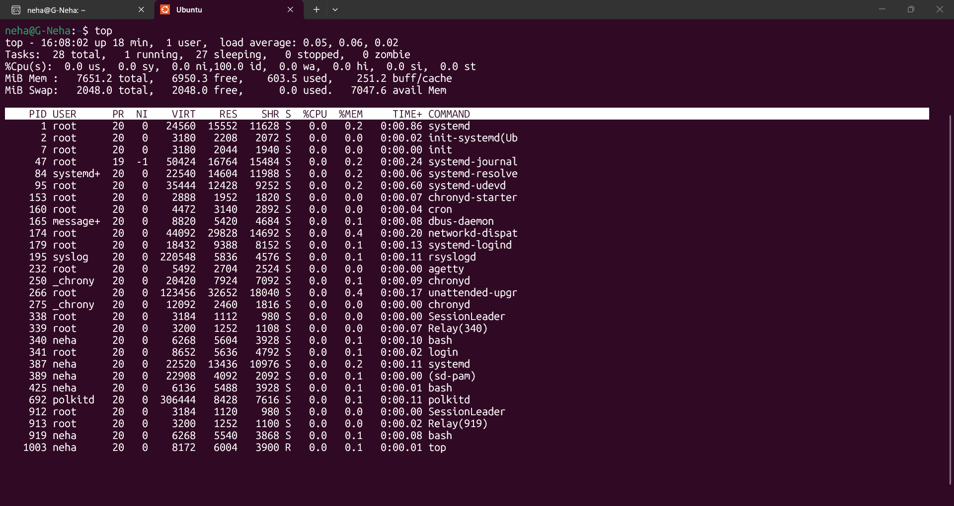
Code:
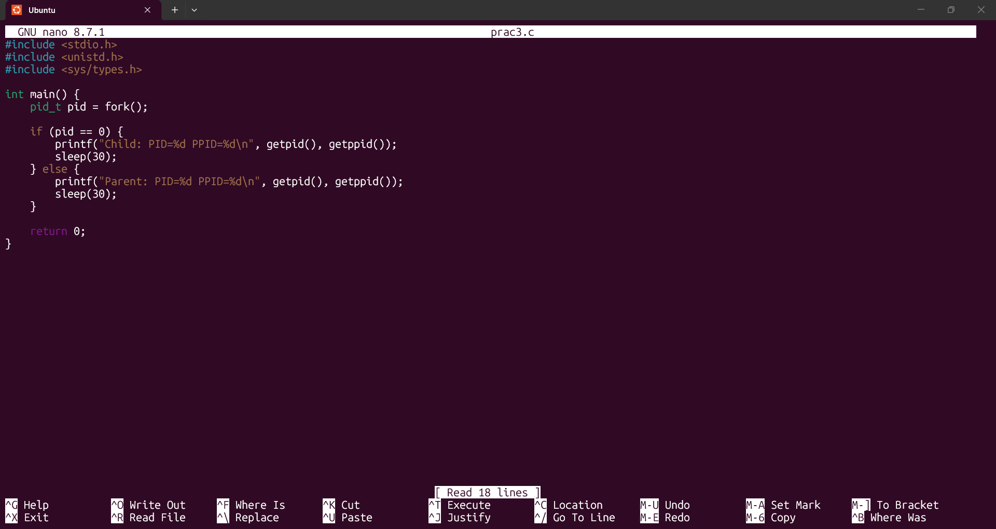

Observations:
- fork() creates a parent and child process with different PIDs.
- The child's PPID matches the parent's PID.
- During sleep(30), both processes are in the Waiting/Sleeping state.
- ps, top, and /proc can be used to monitor their states.
- After 30 seconds, both processes terminate and disappear from /proc.

